Lab#5

Objective: To learn conceptual and logical DW Design

1. Draw M/ERDs for the following scenarios represented by ERDs and

business rules to ease your task.

1. Scenario 1: Advertising

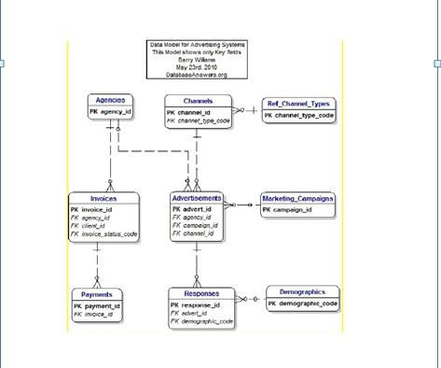

Business Rules

1. Advertisements are placed by Agencies.

2. Advertisements are placed by Channels, such as TV or Print.

3.Advertisements can be part of a Marketing Campaign.

4. Invoices are produced and result in Payments.

5. Advertisements result in Responses.

6. Responses can be analysed by Demographics.

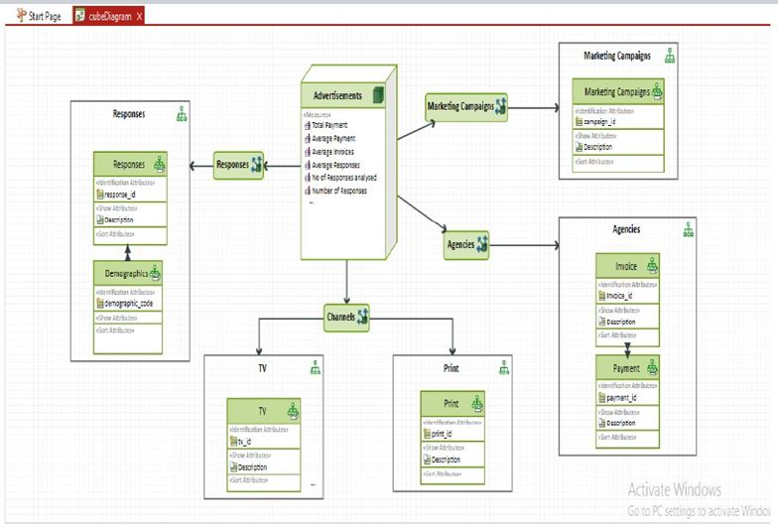

b.Scenario 2: Amusement Parks

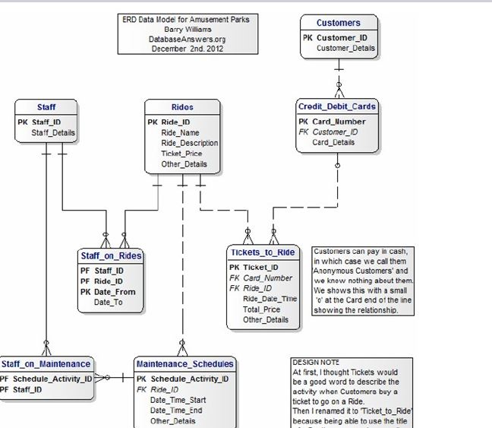

Business Rules

1. Rides are available.

2. Customers use Credit or Debit Cards to buy Tickets to Ride.

3. Staff operate the Rides.

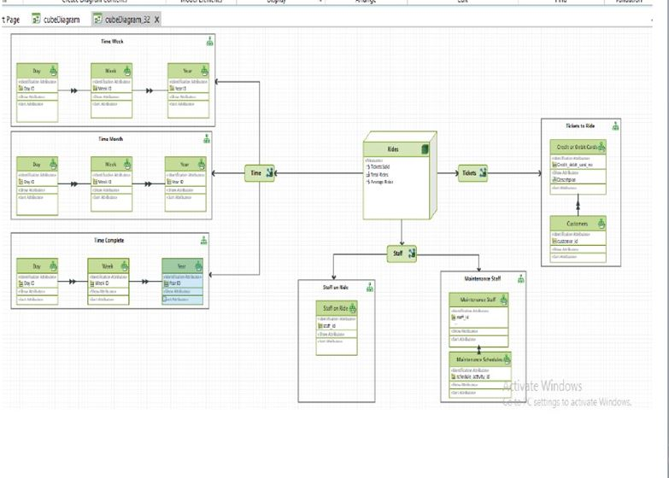

C.Scenario 3: Clown registry

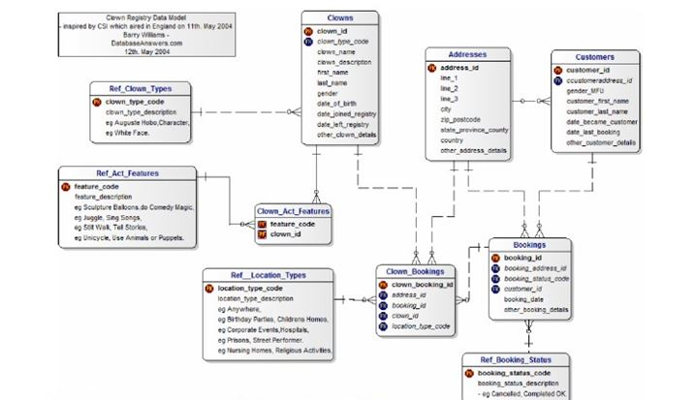

Business Rules

1. People registered as Clowns are stored in the Clowns Table.

2. A Clown can have Acts with specific Features.

3. Clowns accept Bookings to perform at specific Locations for specific

Customers.

